*Review of Borwankar, Wasan (1983)*

Brief Description of the problem:

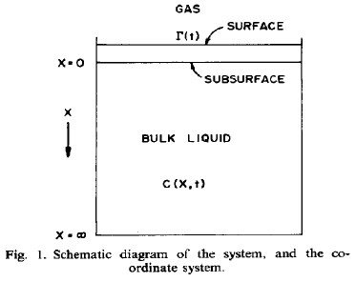

Initially the surface has no surfactant molecules but with the passage of time they will diffuse from the bulk and accumulate in the surface. This movement occurs because the macrostate with molecules in both surface and bulk has a *higher entropy* compared to the macrostate where the molecules reside only in the bulk. (Adsorption will also release energy further reducing the change in free energy, but in this idealized case we do not consider the enthalpy of adsorption)

The governing equation is the Fick`s second law.

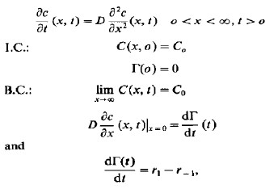

To simplify the governing equations :

* Take Laplace transform of the governing equations to get

$$sC\left(x,s\right)- Co= D*\frac{∂^{2}C\left(x,s\right)}{∂x^{2}}$$

Where C(x,s) is the Laplace transform of c(x,t)

Co is initial concentration in time domain

* The above equation is a standard 2nd order ode in x. The solution after using the Boundary conditions is
$$C\left(x,s\right)=\frac{Co}{s}+\left(C\left(0,s\right)-\frac{Co}{s}\right)*\exp\left(-x*{\left(\frac{D}{s}\right)}^{0.5}\right)$$

* After taking the Laplace inverse of the above equation and substituting C in the 2nd boundary condition we arrive at the following equation

Screenshot007.jpg

After this step the paper presents two different mathematical models to numerically simulate the results of this idealized problem. The simplifications have been elaborately described.

The first method is a detailed and accurate. The final formula is given by.

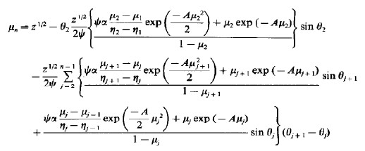

Where,

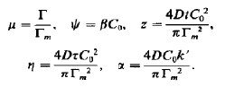

Comparison of the results presented in the paper and the one reproduced using MATLAB:

Color coding ( Reduntant since it is easy to compare even without this)

Blue – Ψ = 20, α = 0

Red - Ψ = 2, α = 0

Green- Ψ = 20 , α = 2

Cyan – Ψ = 2, α = 2

The Math method used is *not Newton Raphson* since it has a high running time, needs a lot of hard coding and often gives physically meaningless results.

In the method used we exploit the fact that mew has to lie between 0 and 1. Take 500 guess values evenly spaced between 0 and 1 and check if the calculated value is around the guess value. Whichever value has the least absolute difference (between guess and calculated value) is considered the answer. Although this method is simple, it guarantees a root between 0 and 1 with a maximum possible absolute error of 0.002.

A = 2

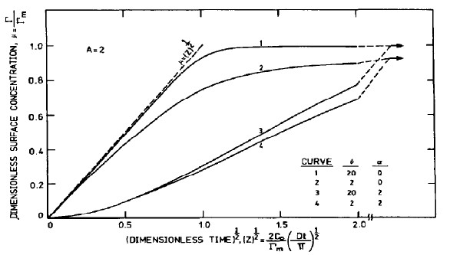

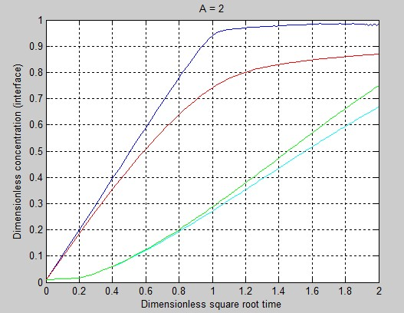

A = 0

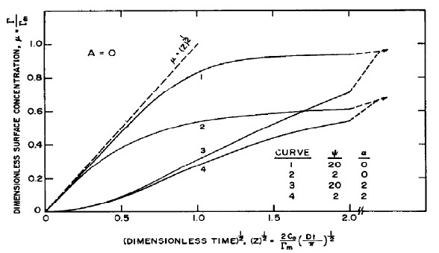

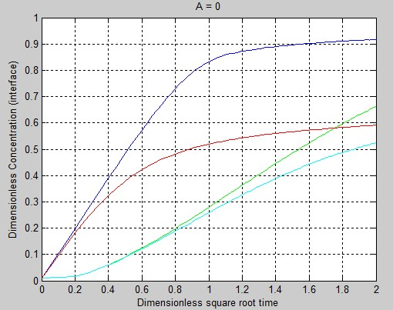

Note : A = 0 corresponds to the results for Langmuir isotherm

A = -2

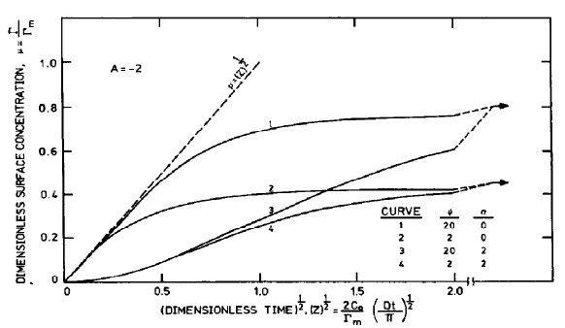

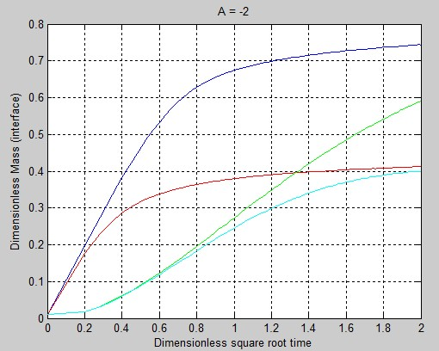

The second method used is called ‘The simplified diffusion-kinetic model’

This is a much simpler method which can be used to get reasonably accurate results with minimum possible computation. (Since this paper was published in 1983, this model might have been much more useful back then)

The derivation is straightforward and described well in the paper. The final equation is given by:

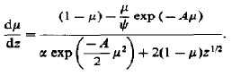

Where all symbols have the same meaning as that in the detailed model.

The above equation is a simple o.d.e . It was solved using Runge Kutta method (ode45 in MATLAB)

Color coding

Blue - α = 0

Green – α = 0.5

Red - α = 2

Note: In the paper they have plotted both the simplified and detailed model together and there is no graph exclusively containing the plots for the simplified model. Yet in our graph only the results from the simplified results are plot which must be compared with the dotted lines in the graphs given in the paper.

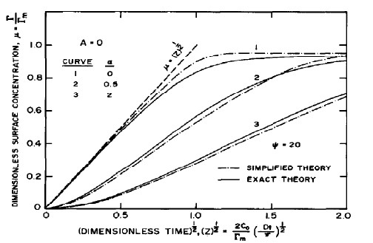

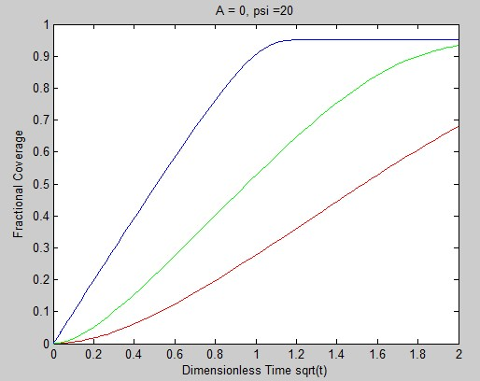

(Compare only with the dotted lines)

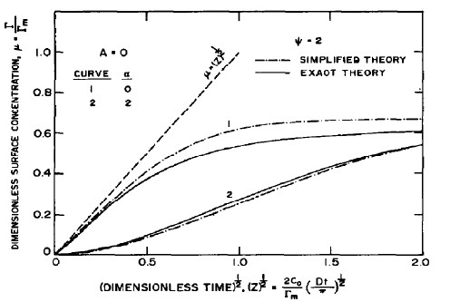

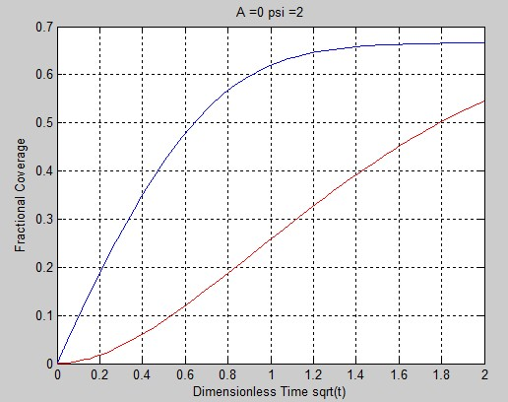

(The above plot has been scaled to improve clarity)